**Ideation Phase**

**Define the Problem Statements**

|  |  |
| --- | --- |
| Date | 16 June 2025 |
| Team ID | LTVIP2025TMID56012 |
| Project Name | OrderOnTheGo |
| Maximum Marks | 2 Marks |

**Customer Problem Statement Template:**

To define the core problems faced by users and restaurant owners in local food ordering scenarios, and use those insights to guide the development of *OrderOnTheGo*.

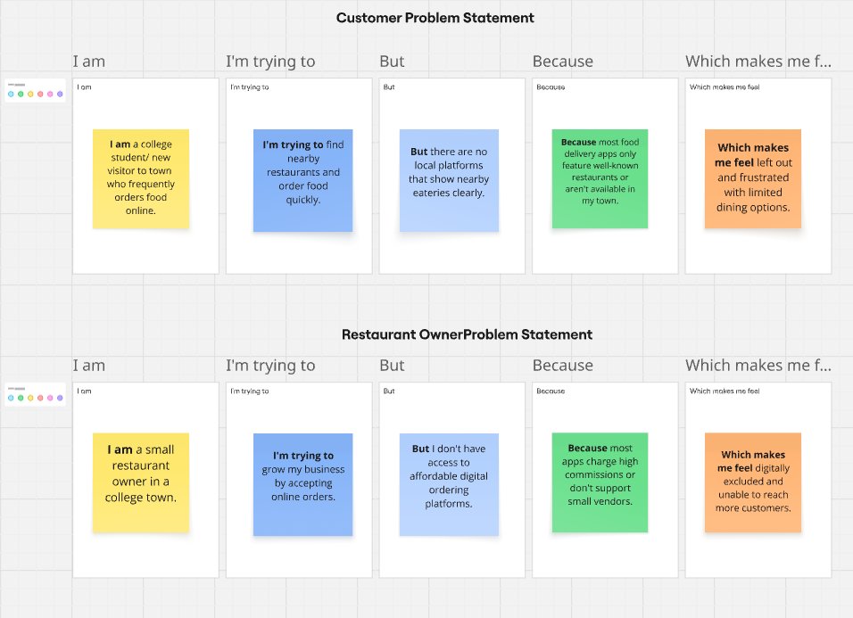

Link : https://miro.com/app/board/uXjVIj4I_7c=/?share_link_id=867770432634

Reference: <https://miro.com/templates/customer-problem-statement/>

|  |  |  |  |  |  |
| --- | --- | --- | --- | --- | --- |
| **Problem Statement (PS)** | **I am (Customer)** | **I’m trying to** | **But** | **Because** | **Which makes me feel** |
| PS-1 | **I am** a college student/ new visitor to town  who frequently orders food online. | find nearby restaurants with good food | there is no dedicated platform for local options | big food delivery apps don’t support smaller towns/restaurants | left out, with limited choices |
| PS-2 | a restaurant owner in a local area | reach more customers and manage online orders | I don’t have access to any digital ordering system | most platforms are expensive or don’t onboard small vendors | helpless and digitally excluded |